Business Information Systems

Ennio da Silva Vitor –

Project: Google Trends – Analysis

12/02/2016

Introduction

In few words Google Trends is an application where we can search and analyse on the internet what people are interested for or what people are not interested for.
This is a good tool, however, we must have special attention on the way that Google’s Inc. systems calculate the universe of reference. As it takes the universe from their own users. The universe is calculated by index, generating a value of a total of searches found from a period of time and numbers of searches.
We have to consider that there are many other web sites to search for information too, although Google is one of the must used ones.

Terms in decline
This section shows the terms in decline which are words that people are slowly stopping to search on the internet. For this project, there are two terms (‘USB flash drive’ on figure 1.4 and ‘digital cameras’ on figure 2.4).

USB flash drive
The figure 1.4 shows the index of searches from 2005 to begin of 2016. On this graphic is possible to see that ‘USB flash drives’ term is not long interesting at begin of 2016 as it was in 2005, although it is still in search results, it means that people still use this technology. ‘USB flash drives’ are devices to store data, and 11 years ago it was one of the few sources available for that purpose, now a day, among of many technology innovation we have cloud stores that are way cheap, and connected to other services, provide extra services as connectivity between multiple devices that improve the access to the saved data.

Figure 1.4: The decline of ‘USB flash drives’ searches
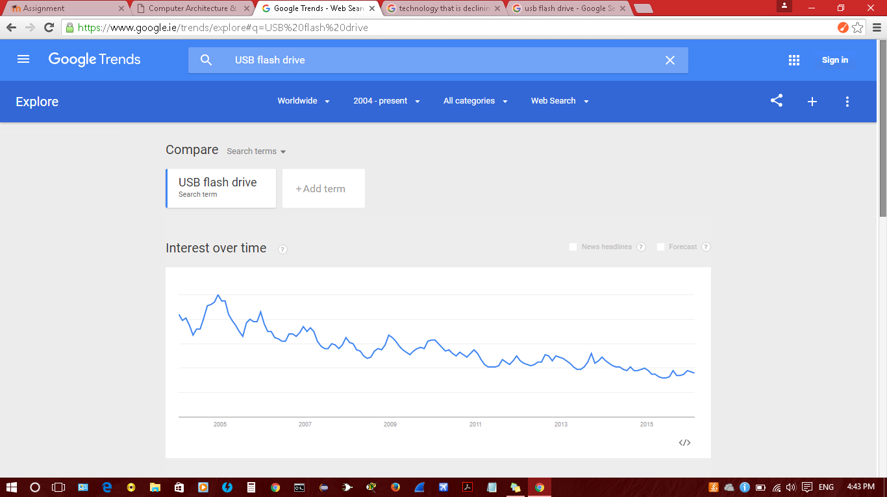
Digital Cameras
On the figure 2.4 the searches for ‘Digital Camera’ have been declining strongly, it does not mean people are not searching for this term at all, it is just a transition from a device that have a unique function to a device with many function, for example: a smart phone that have the same function as a Digital Camera plus many other solutions.
Also on the figure below, we can see the live cycle of this product is really short, not comparing with the old cameras to shot pictures but looking only at the moment when the digital cameras were created until now a day, and as a sample of the period, on Google Trends we can look back 11 years and see that this technology have been in decline since the begin where the searches was high but in a short period of time it starts to decline.

Figure 2.4: The decline of ‘digital cameras’ searches.
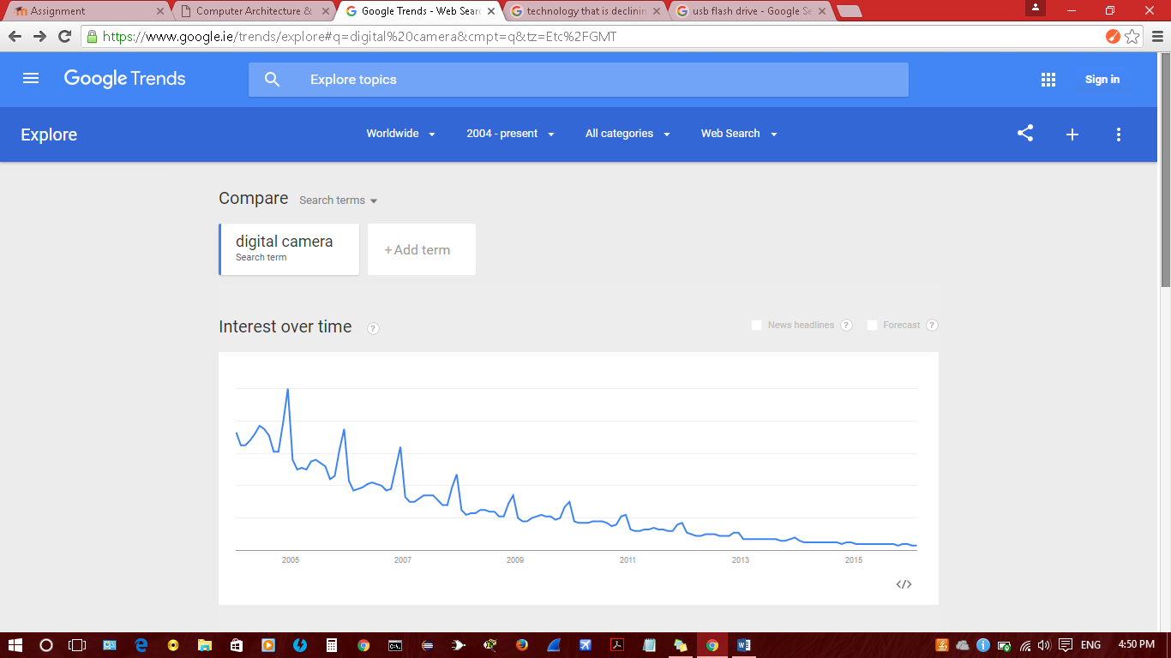

Terms on the increase
Also for this project the terms on the increase will cover two examples, the term ‘Google’ and ‘driverless cars’.

Google
As Google Inc. keeps researching for new technologies to satisfy their users, the result of it is, people identify Google’s tools as a main source of information. On the figure 3.4 we can see that from the last 11 years more and more people are looking for this term.

Figure 3.4: The rising of searches for ‘google’.
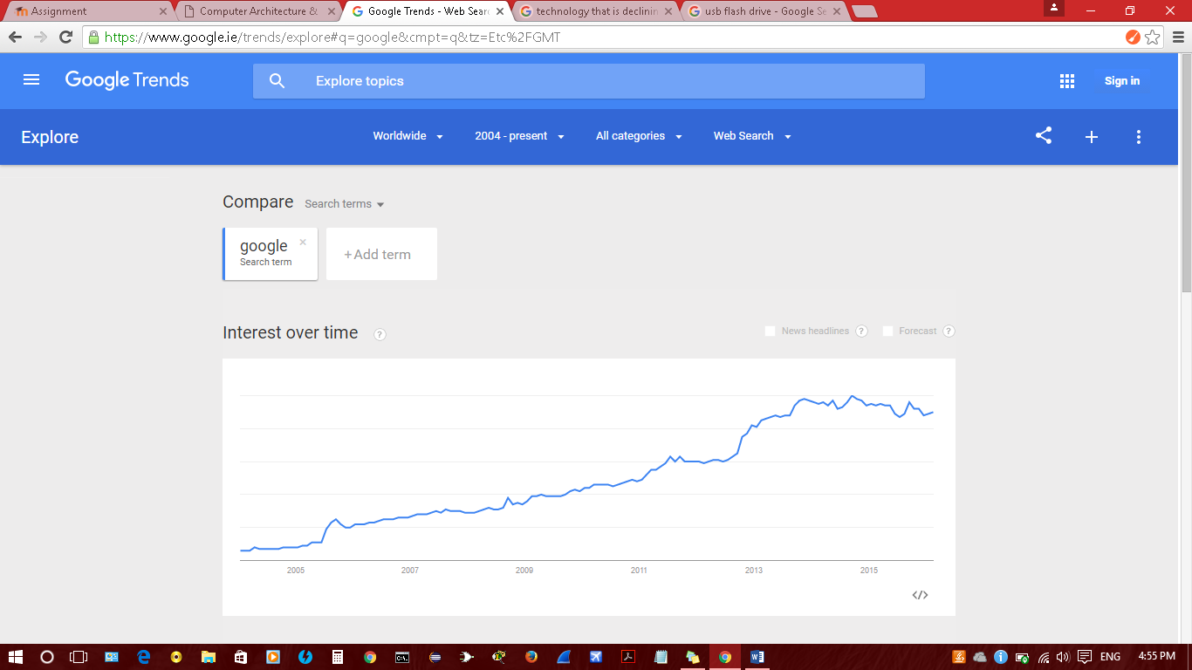

Driverless cars
The idea of a driverless car is old, but the technology to make it a reality was far away, however as shown on figure 4.4, from the last 5 years people are searching more for this term what means that the necessary technology to create a driverless cars is coming out, as people are more curious to learn how it works.

Figure 4.4: The rising of searches for ‘driverless cars’.
